*SMART TIVI QNED 4K 100 inch – LG 100QNED86AS

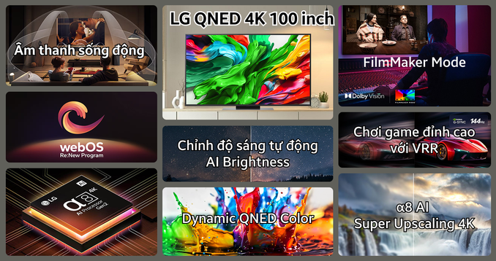

*LOA ÂM TRẦN 2 ĐƯỜNG TIẾNG - BOSE DM3C

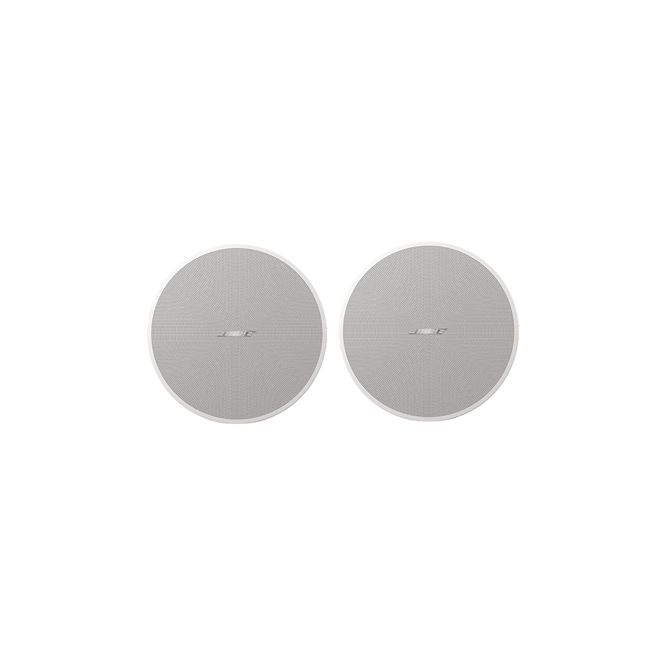

* AMPLY - PEARLLER ST2650
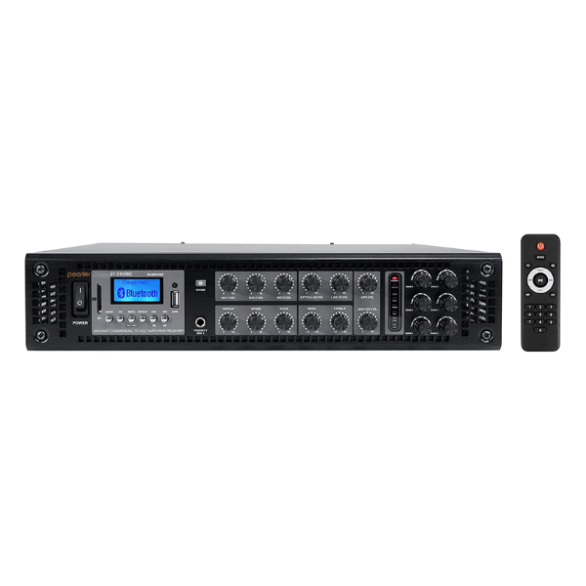
* BỘ THU MICRO 8 MIC CỔ NGỖNG - ATS ST-209N

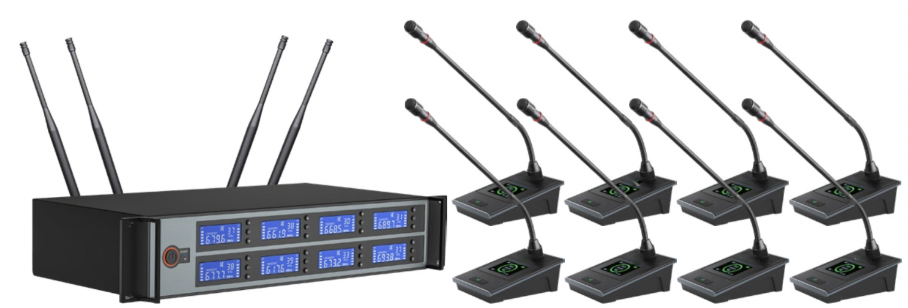

* CAMERA HỘI NGHỊ HD 1080 30 FPS - LOGITECH PTZ PRO2

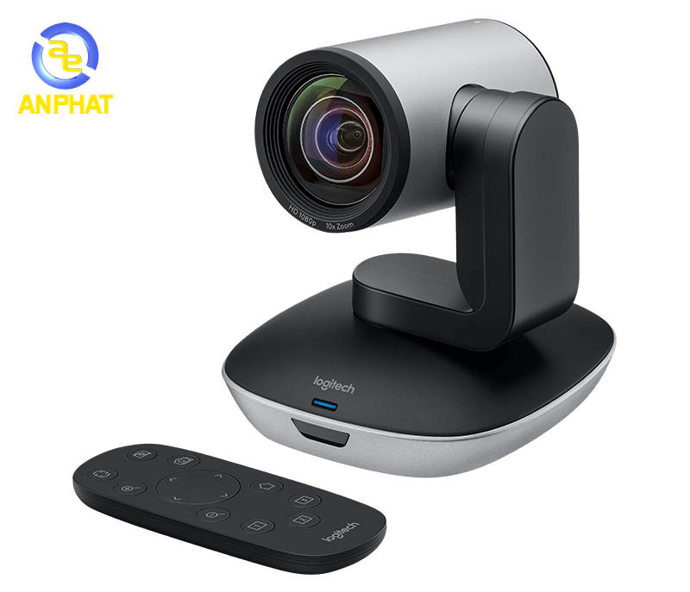

* COMPUTER CONECTIVITY (KẾT NỐI MÁY TÍNH) USB 2.0 FORM FACTOR DESKTOP – ARTURIA MINIFUSE 2
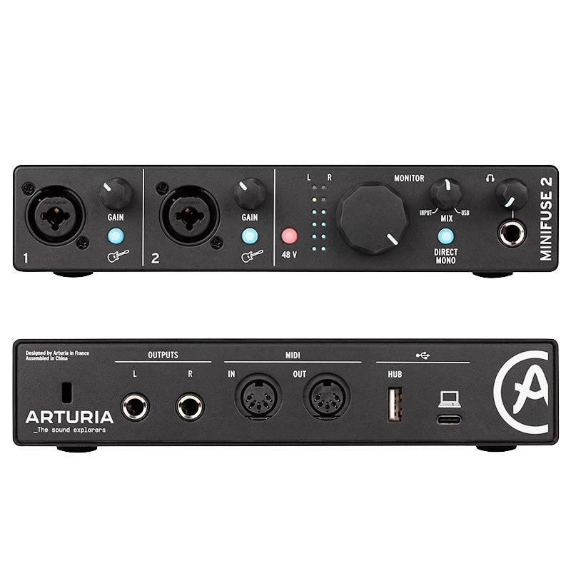

BỘ CHIA HDMI 1 RA 4 – UNITEK V1109A
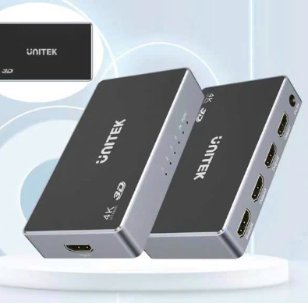

MÀN HÌNH 24 INCHES PROFESSIONAL – DELL 2419H